Homework Chapter 44

1. Exercise 44.1

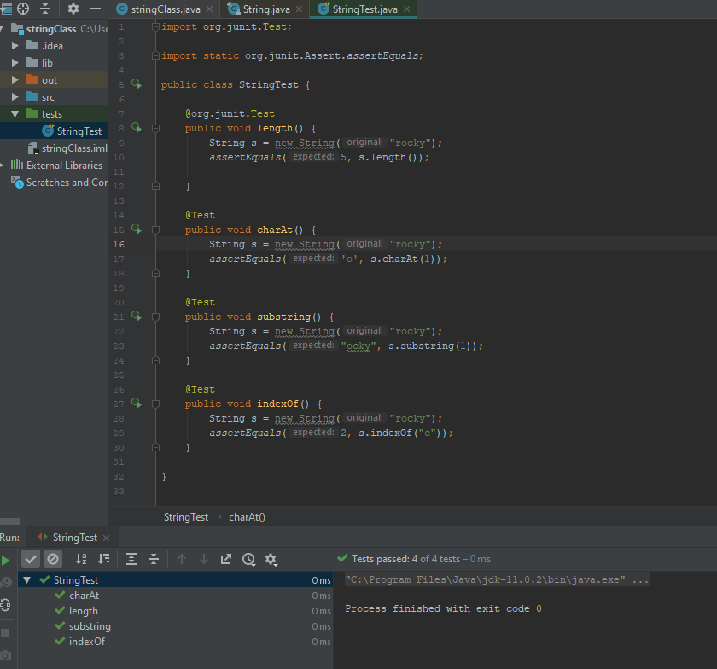

2. Exercise 44.3

